**Task-3**

**Azure CLI :** Azure command line interface

The Azure Command-Line Interface (Azure CLI) is a powerful tool that allows you to manage Azure resources from your command line. It provides a way to automate tasks, create and manage infrastructure, and interact with various Azure services without relying on the Azure portal's graphical interface.

**az login**: To login to our azure account

**az account show** : To see our account details.

To represent the data in table format:

**az account show –output=table**

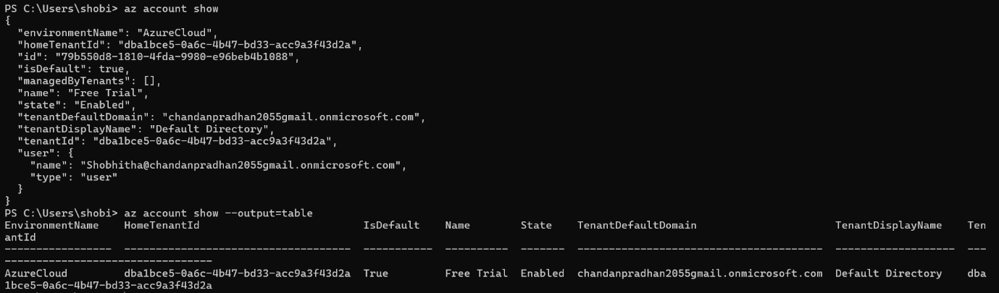

**To shift the subscription** :

az account set --subscription "79b550d8-1810-4fda-9980-e96beb4b1088"

* **To see the list of resource groups:**

PS C:\Users\shobi> **az group list**

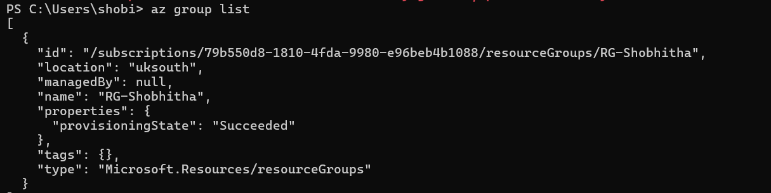

* **To get data in table format:**

Az group list –output=table

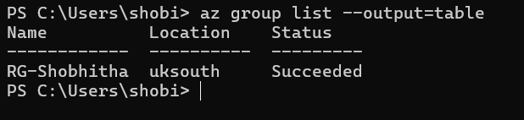

* **To update the resource group:**

az group update –name RG-Shobitha –tags Sg-devops-batchh

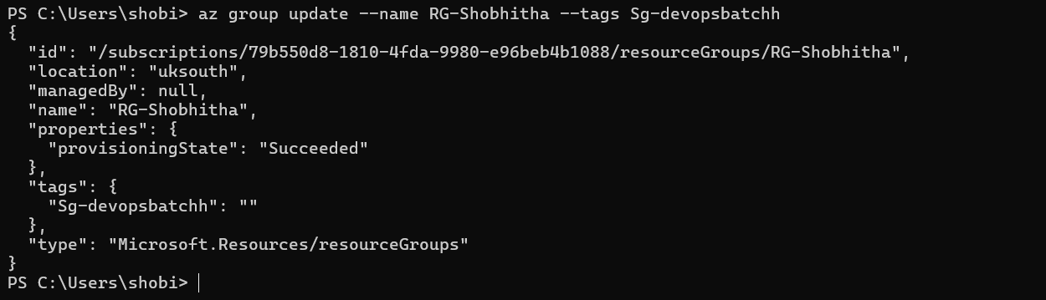

* **To delete the resource group**:

az group delete -n (name of the group)

App service plan:

* **To create the appservice plan**:

az appservice plan -g (resorce group name) -l (location) -n (name of the app service)

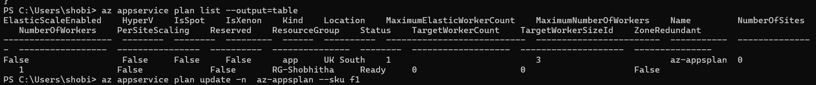

* **To update the appservice plan** :



* **To delete the app service plan:**

az appservice plan delete -n (name of the app service)

**Appservice:**

* **To create the app service**:

az webapp create -g **(**name of the resource group) -p(plan name) -n(name of the web app )



* **To want data in table:**

az webapp list –output=table

* **To delete the app service**:

az webapp delete -g (name of the resource group) -n (name of the web app)

**Storage account:**

* **To create the storage account**:

Az storage account create -g(resource group name) -n (name) -l(location) -sku(LRS_Standard)



* **To create the container in storage account**:

az storage container create -n (name of the container) –account-name(Sa-name)

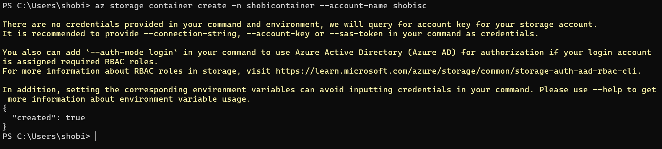

* **To delete the container**:

az storage container delete -n(name of the container) –account-name(Sa-name)

* **To delete the storage account**:

az storage account delete -g(rg name) -n(name of the storage account)

**Keyvault:**

* **To create keyvault:**

az keyvault create -g (resorce group name) -n (name of the keyvault)

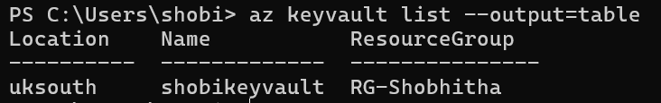

* **To delete the keyvault:**

az keyvault delete -g(rg name) -n (name of the keyvault)